**6A – Maxwell-Ampere Law, Part 1**

**Topics:** Maxwell-Ampere law, conservation of charge, E- and B-fields for a charging capacitor.

**Summary:** After first converting the Maxwell-Ampere equation from differential to integral form, students draw conclusions about  and  for a circuit with a charging capacitor, and compare them with what’s predicted by the static form of Ampere’s law. They are then asked to compare these incorrect predictions with those for the full Maxwell-Ampere equation, and consider how this is related to the continuity of field lines for a divergenceless field (the vector field ).

**Written by:** Charles Baily, Michael Dubson and Steven Pollock.

**Contact:** Steven.Pollock@Colorado.EDU

**Comments:** Around 80% of students completed (or nearly completed) these activities within ~25 minutes. The other activity on this topic (Maxwell-Ampere Part 2, #6B) can also be done in approximately 25 minutes, so the two parts could potentially be used in the same class period, or just split between two classes. Instructors should be sure the initial task of converting the full Maxwell-Ampere equation from differential to integral form is done correctly; 40% of our students incorrectly substituted  for the open-surface flux integral of  (this was an incorrect application of Gauss’ law, where the flux integral must be over a closed surface). Many students were confused about the sign of the net flux of the current density in a region where a capacitor plate is charging – usually because they were not considering the different directions the area vector points in around the Gaussian surface; many were incorrectly thinking that a net charge flowing into the volume would correspond to positive flux. About 1/4 of our students were confused by the questions regarding charge conservation, thinking they were somehow instead asking about whether there was an equal but opposite amount of charge on the two capacitor plates – the wording has been changed slightly to make this less ambiguous. In a handful of cases, students initially believed that charge was actually flowing through the space between the capacitor plates, so that the charge flow was continuous through the circuit. Students may need to be reminded that the divergence of the curl of a vector field is always zero.

**A.** The full Maxwell-Ampere Law in differential form is:



Rewrite this equation in integral form using Stokes’ theorem. Be sure to show all of your steps.

You may continue, but be sure to check your answer with an instructor.

**B.** Consider a capacitor in the process of charging up. The circular plates have radius , area , and are so close together that fringe effects can be ignored. A current  is flowing in the long, straight wires.

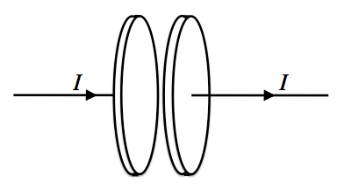

Sketch the E-field between the plates in the diagram below, which shows the plates edge-on. Is  between the plates *positive*, *negative* or *zero*?

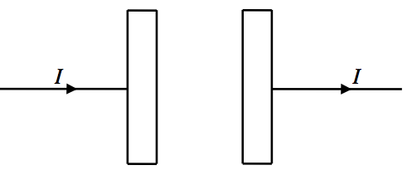

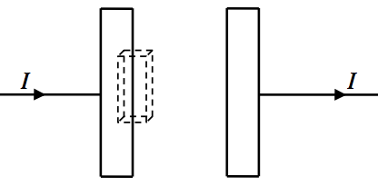Consider the surface of an imaginary volume (dashed lines, at left) that partly encloses the left capacitor plate. For this closed surface, is the *total* flux of the current density  *positive*, *negative* or *zero*? Briefly explain your answer.

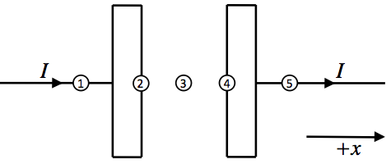

**C.** For each of the five points in the diagram above (labeled 1-5), fill out the table below to indicate whether the quantity in each row is *positive*, *negative* or *zero* at that point. Be sure your answers are consistent with the continuity equation: .

|  |  |  |  |  |  |
| --- | --- | --- | --- | --- | --- |
|  | 1 | 2 | 3 | 4 | 5 |
|  |  |  |  |  |  |
|  |  |  |  |  |  |

Now, explain in words how your entries in each column are consistent with charge conservation.



**D.** Suppose the original Ampere’s law  were correct without any correction from Maxwell (it’s not, but suppose for a moment that it is). What would this imply about  at points 2 and 4 in the diagram? [Hint: What is the divergence of the curl of a vector field equal to?]

Still using the uncorrected Ampere’s law , fill out the table below to indicate whether  is *positive*, *negative* or *zero* at points 1, 3 & 5.

|  |  |  |  |  |  |
| --- | --- | --- | --- | --- | --- |
|  | 1 | 2 | 3 | 4 | 5 |
|  |  |  |  |  |  |

Now, fill out the table below for points 1, 3 & 5 using the FULL Maxwell-Ampere Law (given on the first page) to indicate whether the quantities are *positive*, *negative* or *zero*.

|  |  |  |  |  |  |
| --- | --- | --- | --- | --- | --- |
|  | 1 | 2 | 3 | 4 | 5 |
|  |  |  |  |  |  |
|  |  |  |  |  |  |
|  |  |  |  |  |  |

Compare your answers for  in the two tables above (they *should* be inconsistent). Which set of answers is consistent with the equation ? Explain your answer in terms of the properties of field lines for a *divergenceless* field (in this case, ).